ELECTRICAL PEDESTRIAN SWING-GATE
Model: 884

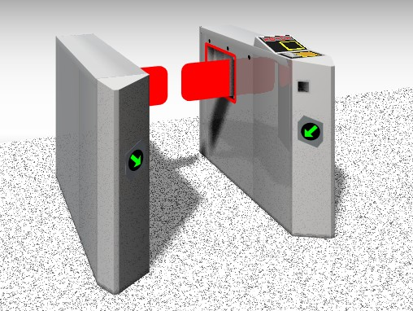

Principle
A sensor controlled passageway with glass wings to prevent unauthorized passage provides excellent access control. Designed to be in sight of reception staff, the Argus takes the problem out of checking individual passes whilst allowing authorized persons to pass unhindered. The unit is at its optimum when used in conjunction with a hands-free access system which allows the glass wings to stay in the open position until an unauthorized person is detected.

Finish
- Steel, painted according to RAL
- Stainless steel, satin finish
Other models on request

Construction
Casing and guiding tube sheets of high-quality
Glazing: 10 mm toughened glass

Door leaves
- Normal height, rectangular
- Extra height, rectangular
Customized design by agreement

Reader interface
Compatible with access control systems standards
- serial interfaces
- field bus cross linkage
Special interfaces, signal exchange with building services automation and connection of customer supplied control elements available on request.
Export variants on request

Model: 884

Operation
The door leaves open and close automatically.
Adjustable modes of operation are:
- open ground state
The door leaves are being closed automatically as soon as an unauthorized passage is registered.
- closed ground state
The door leaves are being opened automatically in the resp. passage direction and then closed again.
Entry direction | Exit direction
‧clear | ‧clear
‧locked | ‧locked
‧electrically controlled | ‧electrically controlled
。by an access control system | 。by an access control system
。manual | 。manual

Electrical Equipment
Control integrated in the unit supply: 230 V AC 50 Hz

Options
- Installation of card readers
- Signal equipment
- Control desk or panel for remote control (release & block)
- Mode selection switch
- Railing elements for flow guidance or as barrier in a suitable design
- Counting mechanism

