ELECTRICAL TRIPODE TURNSTILE
Model: Ww-882

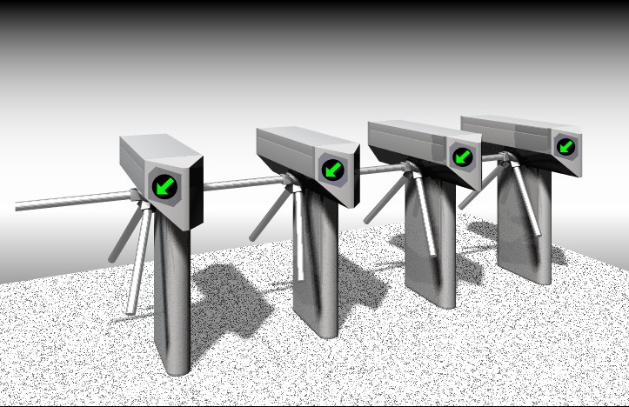

Description

The Ww-882-316 series of pivot barriers are designed to control pedestrians entering or existing restricted areas, usually under surveillance, in low security situations. The rotation is 3 x 120^{o.} This model of a tri-arm design can be used in two directional control applications with high usage of pedestrian traffic such as:

. | Subway platform
. | Libraries
. | Airports
. | Sport stadiums
. | Factories
. | Museums
. | Amusement Park

Housing

The weather - proof housing in stainless sheet is 1.5mm thickness.

Technology

The electric bolt locking mechanism is quiet & utilizes an encoder for position sensing. It is to ensure smooth rotation & 3 x 120º indexing, as well as hydraulic braking & positioning of the turnstile bars.

Features

A special feature is the manually free releasing lock for the passageway can be used as an emergency exit.

Model: Ww-882

Operations

. | Entry and exit controlled
. | Entry controlled and exit permanently free
. | Exit controlled and entry permanently free
. | Entry/Exit access/denied indicators on top cover

Controller

The controller provides interfacing from associated access control devices to activate the bi-directional release mechanism. All inputs & outputs are optical-isolated & incorporate solid state available with reset key switches if required. All units can be provided with built-in or externally fixed badge readers or keypads. Operation of the systems may be stand alone or on-line with a connection to a central computer for time & attendance recording & other data acquisitions.

Technical Data

Power consumption: 200W | Weight: 60 Kg.
Voltage: AC 220V | Frequency: 50-60 Hz
R.H.: 20% -98%.
Temperature: 0⁰ to 50⁰ C (Accessories may be needed below 0⁰ C.)

